Notes on p4:

P9 of analysisStability pdf

Take derivative, at t=0 derive = b

At t=-h, dy/dt=f_b

For part b, find the conditions that make it reasonable, passes through all Y points

(find order of polynomial), h is only with F

Part a:

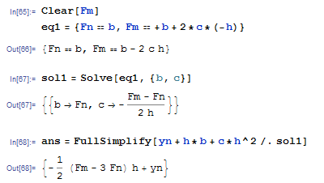

Part b:

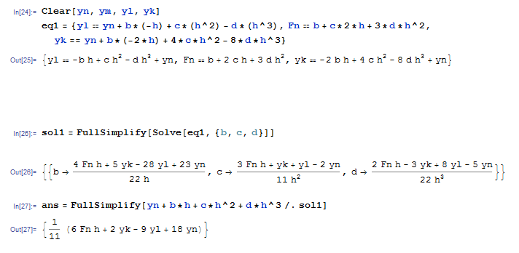

vv